Dulwich Difference

At Dulwich College Suzhou our vision is to nurture students to Live Worldwise — to become confident, compassionate, and future-ready global citizens with the skills and character to make a positive difference in the world.

Our Dulwich Difference is defined by three pillars: Live, World and Wise.

<image that represents our students’ strength of character, thrive holistically>

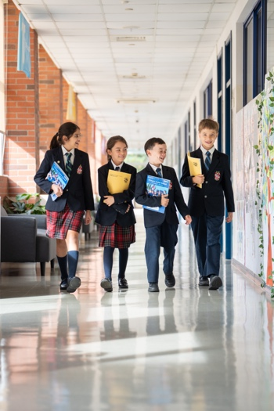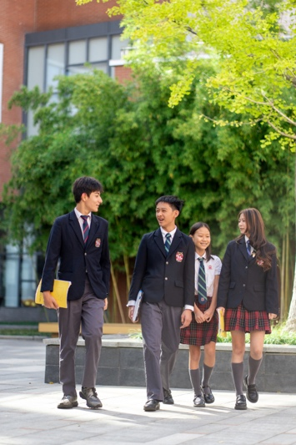

LIVE with strength of character, thrive holistically
We believe a child’s growth begins with strong values and mindset. Across our Dulwich College International community, we inspire students to embrace their unique character and cultivate the values, traits, and inner strengths—resilience, responsibility, respect, inclusiveness, adaptability and global citizenship—that empower them to flourish, lead, and create meaningful change today and beyond.

We educate the whole child. Through a holistic learning experience that offers both breadth and depth, spanning music, sports, STEM, visual and performing arts and much more. Students discover their passions, hone their individual talent, and unlock their full potential. Our students graduate as well-rounded young people who live energetic, balanced, and fulfilling lives.

<image that represents the school’s vibrant WORLD community, truly international and connected>

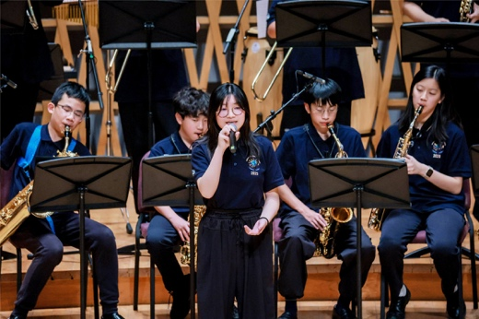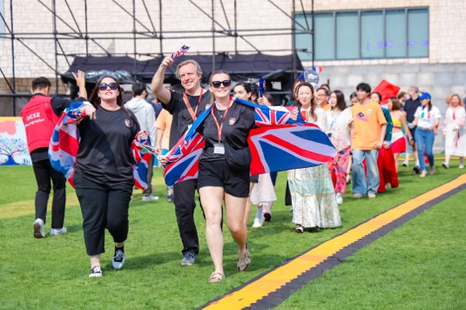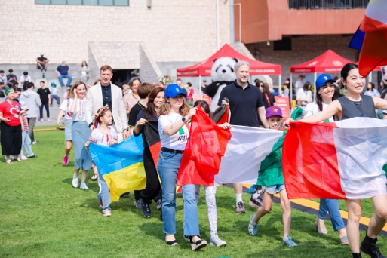

A vibrant WORLD community, truly international and connected
Dulwich College International spans 9 campuses across the globe, alongside its founding school, Dulwich College in London. Students, teachers and community members come together to engage and collaborate through a wide spectrum of exciting, enriching and transformative opportunities - from immersive academic exchanges and inter-school activities like Worldwise Events to innovative joint projects and programmes.

Being part of the Education in Motion family connects all Dulwich College Suzhou to world-class, prestigious resources and a truly global outlook. Our students benefit from exclusive and inspiring partnerships across a wide range of fields, including leading arts institutions like the Royal Shakespeare Company, [month-long immersions in our sister school in Switzerland, swimming with Olympic gold medalists, learning from Nobel Prize winners and business leaders, top-tier academic institutions such as Evidence Based Education, and visionary thought leaders from world top universities.

<image that represents our students pursuing academic excellence, growing future-ready and WISE >

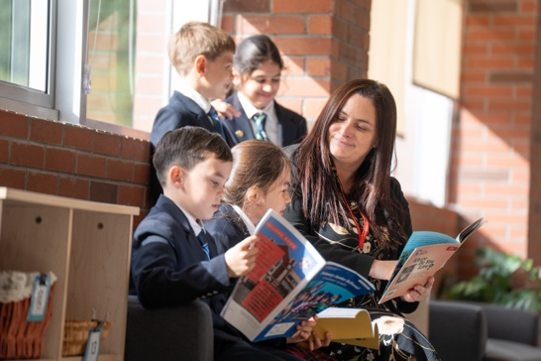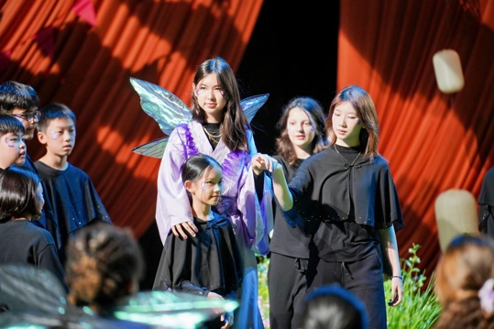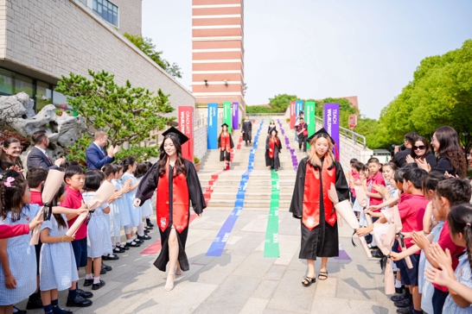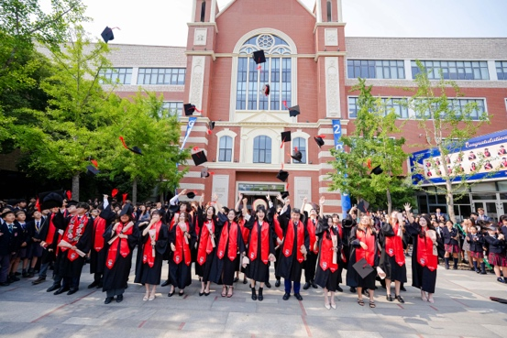

Pursuing academic excellence, growing future-ready and WISE
Dulwich College [International] is dedicated to academic excellence as a shared community commitment. (Our schools consistently achieve top rankings in their respective countries and deliver outstanding results across a range of educational programmes, including IGCSE, IB, and A-Levels. We equip students with robust academic skills to fuel their future success, not only in university but also throughout their onward journey.

Our students gain wisdom in its fullest sense - armed with adapatble skills and competencies, from bold creativity, to insightful critical thinking and confident digital literacy and more, to be fully prepared to navigate a rapidly changing future with purpose and to shape the world for the better.

